Sample Questions: Manufacturing Process I
- A washer with the following dimensions need to made:
outer diameter = 25.4 mm
inner diameter = 12.7 mm
Thickness = 1.5 mm
The fracture stress and strain of the material is 280 N/mm² and 1.0 respectively.
Find
- the total cutting force if both the punches act at the same time and no shear is applied to either punch or the die
- the cutting force if the punches are staggered, so that only one punch acts at a time
- the cutting force if both punches act together and the shear on the punch is 1 mm.

- In a forging process of a long strip (as shown below) the height(h) and length (2l) are 8mm and 20 mm respectively and the coefficient of friction is 0.4. If it is desired that a similar strip of height 5 mm (with all other geometric quantities being the same) is to be forged, such that the maximum pressure in the strip is the same as in the previous case then what are the two possible ways of achieving this?
h
2l

- In a welding process two plates (of Material1 and Material2) are joined by a butt joint as shown in the figure below:
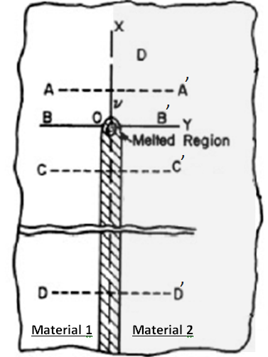

Pictorially draw the change in temperature (T) and residual stress (_{xx}) for the four locations (AA’, BB’, CC’ and DD’) for the following three cases (Hint: Use Three‐Bar Arrangement to answer this problem)
a. Material 1 and Material 2 is same and has low coefficient of thermal expansion
b. Material 1 and Material 2 is same and has high coefficient of thermal expansion
c. Material1 and Material2 have same melting point and coefficient of thermal expansion but Material2 has higher thermal conductivity.

- Which properties of metallic materials may be inferred from interatomic potential curves ? Given below are the interatomic potential curves for iron and copper. Identify which of these correspond to iron and which to copper. Justify your answer. [7]

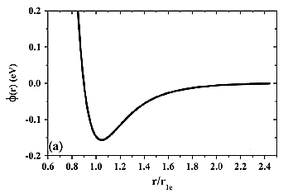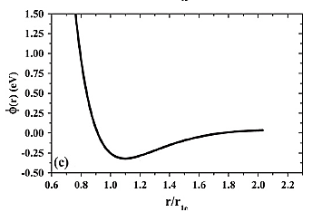
- (b)

