Comprehensive examination Spring 2014
Sample questions of Advanced Heat Transfer (comprehensive examination)

- The schematic diagram in figure 1 represents a blood-perfused tissue layer with metabolic heat generation (${\dot{q}}^{'''}$). Assuming steady-state unidirectional conduction in this tissue, the bio-heat equation in this case is,

$$k_{t}\frac{d^{2}T}{dx^{2}}-{\dot{m}}^{'''}c_{pb}\left(T-T_{A}\right)+{\dot{q}}^{'''}=0$$
wherek_{t} is tissue thermal conductivity, ${\dot{m}}^{'''}$ is the volume of blood flow rate in the tissue, c_{pb} is the specific heat of the blood. T_{A} is the arterial blood temperature. Temperatures at the two sides of the tissue T₀ and T_{L} are known. Obtain the temperature distribution in the tissue and the heat transfer rates through the sides of the tissue.

Tissue
L
T₀
T_{L}
Figure 1: Schematic diagram of tissue layer

- A very short pulse of high intensity current is passed through a thin wire buried in a thick fiberglass insulation layer. As a result, the wire generates (almost instantaneously) heat source Q΄ per meter of its length. Find the followings:
  - Derive the temperature distribution in the insulation. Show all the steps clearly.
  - Determine the time t when the maximum temperature occurring at any distance r from the wire.
  - What is the maximum temperature at that location?
The one dimensional transient heat conduction equation for cylindrical coordinate system is given by,
$$\frac{1}{α}\frac{∂T}{∂t}=\frac{1}{r}\frac{∂}{∂r}\left(r\frac{∂T}{∂r}\right)$$

- The figure shows the triangular cross section through a long bar. A finite temperature difference (θ_{b}) is maintained between the two sides that are mutually perpendicular. The hypotenuse is perfectly insulated. Determine analytically the temperature distribution for steady conduction in the rectangular area, θ(x,y). (Hint: Exploit the geometrical relationship that might exist between the given triangle and a square cross section of length L.)

Figure 2

- A gray surface has a directional emissivity as shown in figure 1.
  - What is the hemispherical emissivity of this surface?
  - If the energy from a blackbody source at 400 K is incident uniformly from all directions, what fraction of the incident energy is absorbed by this surface?
  - If the surface is placed in a very cold environment, at what rate must energy be added per unit area to maintain the surface temperature at 800 K?
Figure 3: ε(θ) vs.θ

- A flat plate radiator in space in earth orbit is oriented normal to the solar radiation. It is receiving direct solar radiation, radiation emission from the earth and solar radiation reflected from the earth. What must be the radiator temperature be to dissipate a total of 1500 W of waste heat from both sides of each 1 m² of the radiator?

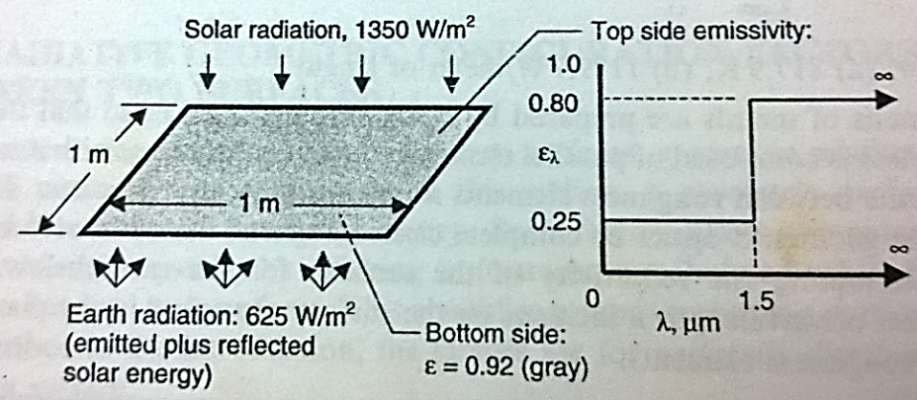
Figure 4

- A thin gray disk with emissivity 0.9 on both sides is in earth orbit. It is exposed to normally incident solar radiation (neglect radiation emitted or reflected from the earth). What is the equilibrium temperature of the disk? A single thin radiation shield having emissivity 0.05 on both sides is placed as shown. What is the disk temperature? What is the effect on both of these results of reducing the disk emissivity to 0.5?

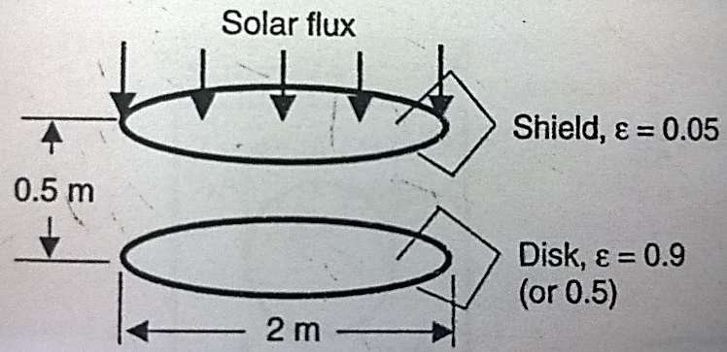
Figure 5

- Consider thermally and hydrodynamic fully developed flow of mean velocity u between two stationary parallel plates of negligible thickness 2H as shown in the figure below. The plates are infinitely long in the plane of the paper and also in the plane perpendicular to the paper. A constant pressure gradient drives the flow. The fluid flows into the channel at inlet temperature $T_{m0}$ and is heated by the two plates with uniform wall heat flux. The heat fluxes on the two plates are different and are denoted q₁ and q₂. Axial conduction and end effects are assumed to be negligible. Determine the temperature field and calculate the Nusselt number associated with heat transfer between the fluid and the channel walls.
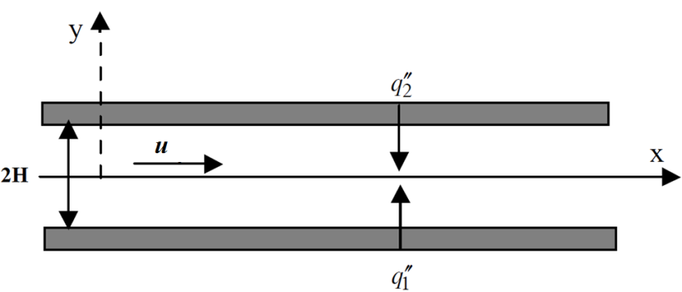

- Solve the above problem when,
- q₁ and q₂ are equal and evaluate the Nusselt number
- When lower plate is subjected to heat flux q and upper plate is insulated i.e. q₁ = q and q₂ = 0.
- Consider thermally and hydrodynamic fully developed flow of mean velocity u in a circular tube of diameter D as shown in figure. The tube is infinitely long. Constant heat flux q is applied on the surface of the tube. Constant volumetric heat S is being generated inside the tube. Include effect of viscous dissipation. show that Nusselt number is given by
$$Nu =192/(44+3λ)$$
$$where λ =SD/q +64Br$$
$Br = u^{2}μ /qD$,
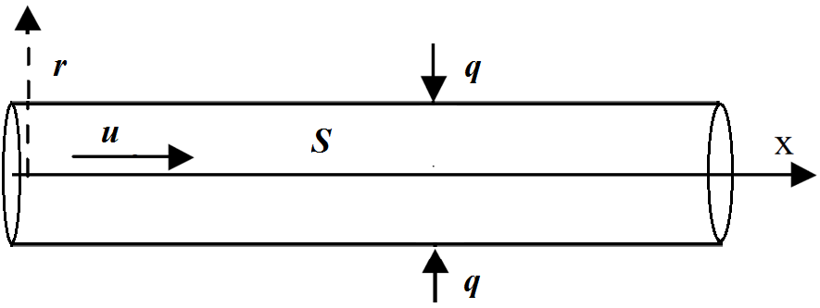
Figure 7

